Day 3 – Product Vision & MVP Definition
Project
ProcurAgent – AI-Powered Automotive Procurement & Supplier Risk Management System
Day 3 Summary
Day 3 focused on defining the product vision, identifying the minimum viable product, breaking the solution into features and modules, prioritizing requirements, and understanding dependencies and business rules.
Concepts Learned
1. Product Vision
A clear statement describing what the product aims to achieve, who it serves, and the value it provides.
For ProcurAgent:
Help procurement teams proactively identify supplier risks and make better procurement decisions.
2. MVP
MVP (Minimum Viable Product) is the smallest version of a product that delivers its core value to users.
ProcurAgent MVP examples:
- Supplier analysis
- Supplier comparison
- Risk prediction
- Risk alerts
- AI recommendations
3. Feature
A specific capability or function provided by the product.
Example: Supplier Risk Prediction is a feature of ProcurAgent.
4. Product Backlog
A prioritized list of features, requirements, improvements, technical work, and other items that may need to be developed.
5. Feature Decomposition
Breaking a large feature into smaller and manageable parts.
Example:
Supplier Risk Management → Data Collection → Risk Calculation → Risk Classification → Alert → Recommendation
6. User Story Mapping
Organizing user stories according to the user's overall journey or workflow.
Example:
Identify Need → Find Suppliers → Compare Suppliers → Assess Risk → Make Decision → Monitor
7. Module
A major functional part of a software system that groups related functionality.
ProcurAgent examples:
- Supplier Management
- Procurement
- Inventory
- Risk Management
- Negotiation
- Dashboard
8. MoSCoW Prioritization
A method used to prioritize requirements.
- M – Must Have: Essential
- S – Should Have: Important but not essential
- C – Could Have: Useful if time permits
- W – Won't Have: Not included in the current scope
9. Business Rule
A rule or condition that defines how a business process or decision should work.
Example:
A new supplier with insufficient historical evidence should be shown with lower confidence rather than fabricated historical performance.
10. Dependency
A relationship where one task, feature, or module depends on another before it can function or be completed.
Example:
Risk prediction depends on supplier and performance data.
11. Prioritization
The process of deciding which requirements, features, or tasks are more important and should be addressed first.
12. Ranking
Arranging items in an ordered sequence according to a specific criterion.
Example: Suppliers can be ranked based on risk, price, delivery performance, quality, and capacity.
13. Sprint
A fixed period during which a team works on a selected set of planned work.
14. Sprint Goal
The main outcome that the team aims to achieve during a sprint.

Diagram / Picture Space
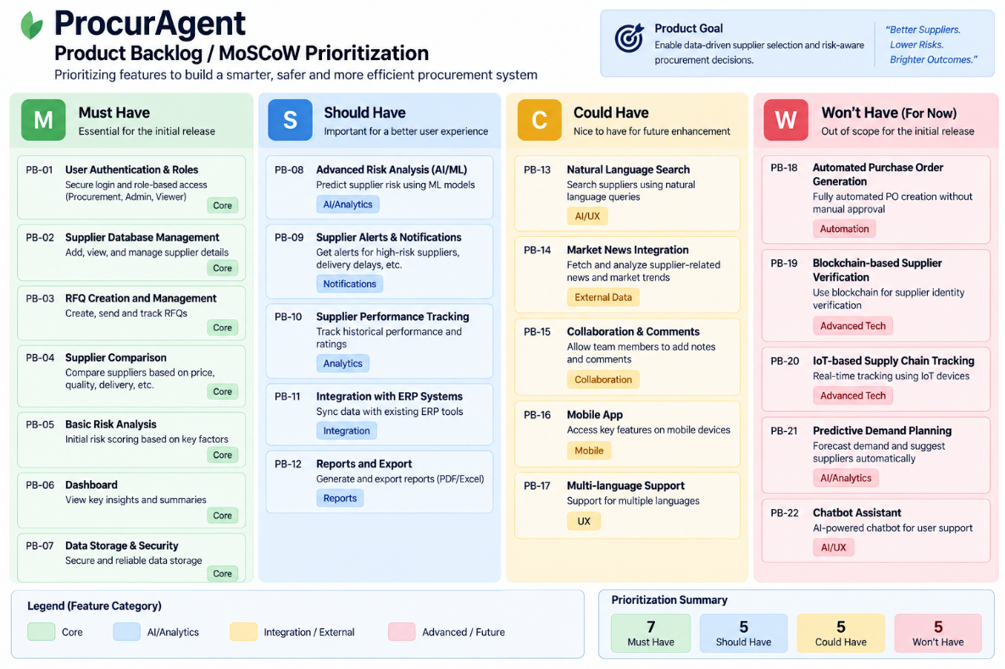
Day 3 Learning Outcome
By the end of Day 3, the concepts of product vision, MVP, features, backlog, feature decomposition, user story mapping, modules, MoSCoW prioritization, business rules, dependencies, prioritization, ranking, sprint, and sprint goals were understood.
Key Takeaway
Product Vision → MVP → Features → Backlog → Decomposition → Modules → Prioritization → Business Rules → Dependencies → Sprint

